Christmas in the UK
Worksheet – elementary

Match the words to the pictures!
Stocking | 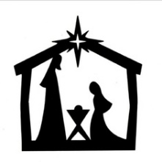
Turkey | 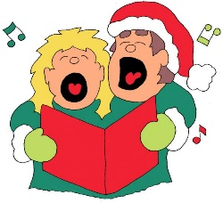
Bauble | 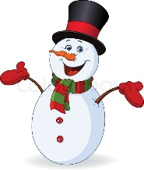
Carol singers | 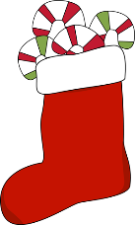
Snowman
Nativity Scene | 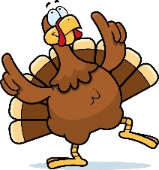

Complete each sentence with one of the words above…

On Christmas Day, British people eat ____________
They put ____________ on the Christmas tree
They put presents in ____________
If it snows, they sometimes build a ____________
Christmas in the UK
Worksheet – pre-intermediate

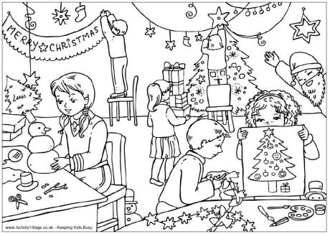

Complete the sentences below with “be” and the correct verb form to say what the children are doing now.
Kamila ____ __________ a snowman. (make)
Pedro ____ __________ ____ decorations. (cut out)
Giuseppe ____ __________ a fake beard. (wear)
Helga ____ __________ the presents to the tree. (carry)
Svitlana ____ __________ an angel on top of the tree. (not put)
Anna ____ __________ her picture to Pedro. (show)
All of the children ____ __________ ready for Christmas. (get)

Write three things you usually do in your family at Christmas. Think about what verb form you need to use. Do you need “be”? Write full sentences.
Christmas in the UK
Worksheet – intermediate

Read the text below about Christmas in the UK and put the paragraphs in order.
Finally, everybody sits down together to play games, watch Christmas films or just spend time together. Many people also watch the Queen’s speech on television or visit the local graveyard to remember relatives. By the time everyone goes to bed they are usually very happy, but also very tired…
When the children wake up they rush downstairs to open their presents. While they are playing with their toys, parents will usually begin cooking Christmas dinner. This is a big meal that traditionally includes turkey, roast potatoes, cranberry sauce and Christmas pudding – a special kind of dessert that is covered in brandy and set on fire!
On Christmas Eve, everybody is very excited. Some people go to church for “midnight mass”, but not everybody. Normally the children will leave a treat for Santa and his reindeer before they go to bed. This can include things like cookies and brandy, as well as carrots or milk for the animals. They also hang up stockings for him to fill with presents.
Before that happens, though, everybody pulls “crackers”, a kind of cardboard tube with games, jokes and a paper hat inside. They also contain a small explosive which makes a “crack!” sound when they are pulled apart. The person who gets the biggest half wins.
Once the children have gone to bed, Santa (also known as St. Nicholas or Father Christmas) visits each house and delivers presents. The presents are usually either put in a stocking or under the Christmas tree. Naughty children don’t get any presents, but they might get a piece of coal if they’re lucky!

What do you think these words mean? Write your ideas in the next box. Use the context to help you. Think: What type of word is it? Is it a good thing or a bad thing?
Speech

Rush

Treat

Stocking

Naughty

Coal

