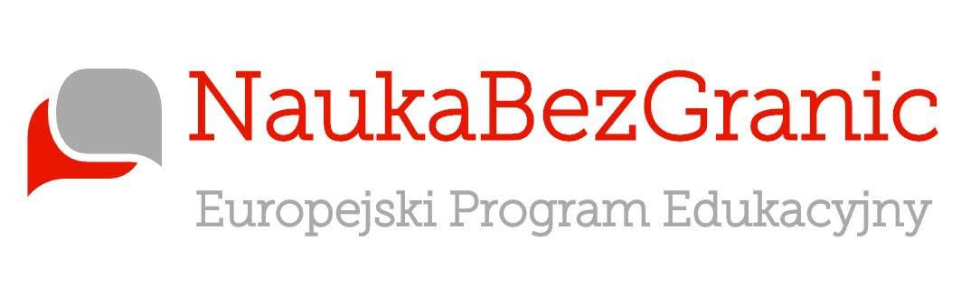
Easter Games
Workshop Vocabulary
Task 1: INTRODUCTION

Here’s a quick list of words and phrases to help you participate in the workshop:
Bounce  Skip  Splat  Competition  Flip | Treasure hunt  Steal  Relay Race  Bunny  Fair

Task 2: SPEAKING AND VOCABULARY
In pairs or groups, research the following Easter traditions in Britain:

- Maundy Thursday 2. Morris Dancing 3. Battersea Easter Parade
Task 3: MORE VOCABULARY
Another Easter tradition in Britain is to eat hot-cross buns, and there’s a little song to be sung!
"Hot cross buns,
hot cross buns,
one a penny, two a penny,
hot cross buns.
If you do not like them,
give them to your sons,
one a penny, two a penny,
hot cross buns.”

Like us http://facebook.com/learningwithoutborders.eu
Make friends with Richie at
https://www.facebook.com/richieatlearningwithoutborders/?fref=ts

Easter Games Workshop
Teachers’ Notes
These activities have been designed to be used before the workshops as introduction and a way of getting students interested and a way to pre-teach vocabulary.
You may also use the material as a follow up activity after the students have attended the event and see how much they remember!

Like us http://facebook.com/learningwithoutborders.eu
Make friends with Richie at
https://www.facebook.com/richieatlearningwithoutborders/?fref=ts

