Fun and Games – worksheet #1
Let’s learn how to play “Conkers!” Match the instructions to the pictures and then put them in the correct order.
Find a conker you like and make a hole. | 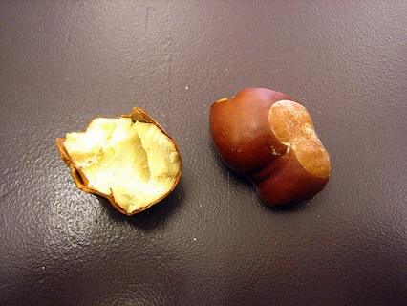
Try to hit your friend’s conker with yours. | 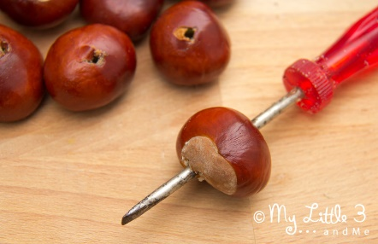
Find a Chestnut tree and look for “conkers” (the seeds of the tree) nearby. | 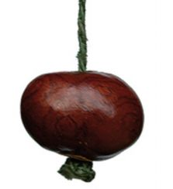
After five tries, it is your friend’s turn to hit your conker. | 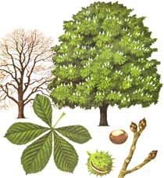
Put string through the hole and tie a knot in the end. | ME NOW!
The first conker to break or fall off the string loses. | 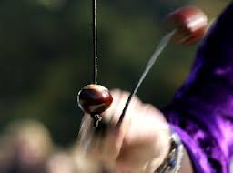

Fun and Games – worksheet #2
Let’s learn how to play “Kerby!” Match the instructions to the pictures and then put them in the correct order.

First player to 1000 points wins! | 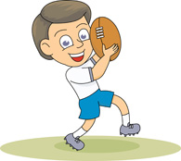
Find a large, bouncy ball. A football is good, a basketball is better! | 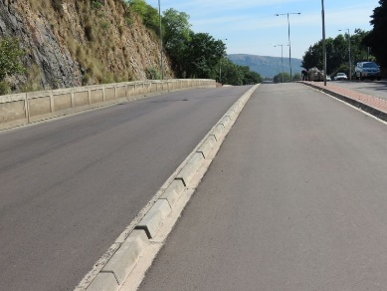
If the ball hits the kerb but you don’t catch it, you get 10 points. Then you go to the middle of the road and try again for another 10 points. If you miss, your turn is over.

If the ball bounces back and you catch it, you get 50 points. After this it is the other person’s turn.
Find a quiet road with two kerbs opposite each other.
Stand on the kerb opposite your friend and throw the ball at their kerb.

