SHAKESPEAERE
Attending Shakespeare’s Theatre

Task 1 VOCABULARY AND READING
Read the text below and complete it with the words below. Make sure first you know all the words.
galleries, ground, surrounded, covered, attending, paid, rowdy, yelling out, middle, props, acquired

_______________ the theater in Shakespeare’s time was very different from _____________ it now, and Shakespeare’s own theater, the Globe, was unlike any modern one. It was probably round, or nearly so, and the roof ____________only the outside galleries; thus, many who went to see the plays got wet in the frequent London rains. The stage jutted out into the audience, and the actors were _____________ on three sides by people who ________ to see the performance.

Nearly half the theater-goers stood on the ____________ around the stage; they were called “groundlings,” and they were a __________ bunch, eating, talking and _______________ anything which took their fancy at the moment. People paying higher prices got seats in the _____________ for their money and a roof to keep off the rain.

No one went to the theater at night. There were no electric stage lights, and the stage was in the ___________ of the audience, lighted by the sun. There was no scenery and very few _________. There were no costumes except for any which the actors ______________ for themselves, so there might be all manner of styles and periods of dress on the stage at one time.

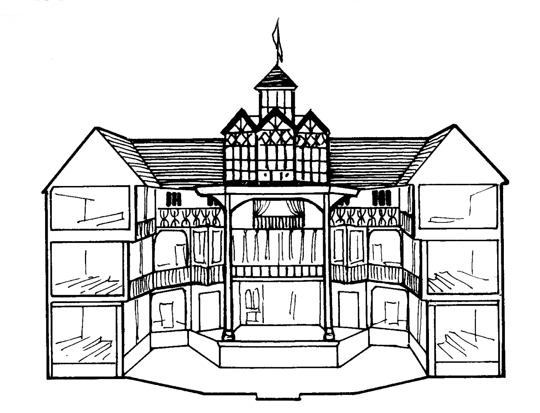
Task 2 READING AND VOCABULARY
Read the text below and comment on the meaning of the highlighted phrases. Try to guess from context:
Today, no courteous theater-goer would think of walking around while a play was on, but Shakespeare’s audiences, especially the groundlings, made no pretense of courtesy, and the playwright who, after all, had been an actor himself, knew he had better write a play filled with action and good stories or he would soon lose the attention of his audience. Shakespeare’s plays are action-packed with all sorts of sword play and buffoonery.

In Shakespeare’s time no women or girls acted in the plays, which is probably the main reason there are many more men’s than women’s parts in his plays. For a woman to act in a play would have been a shameless and serious breach of social custom. Women were played by men, and girls and young women were played by young men or boys who were carefully taught by the older actors. Only later in the seventeenth century did women and girls act, and even then an actress was considered somewhat daring and her character a little suspect.

In 1613 the old Globe Theatre burned to the ground after being set on fire by a spark from a cannon during a performance of Henry VIII.

Task 3 WRITING AND SPEAKING
Look at the texts in Task 1 and 2 and write 10 true/false sentences about attending Shakespeare’s theatre.
When ready, work in pairs. Quiz your partner and see if they can give you correct answers.

SHAKESPEAERE
Attending Shakespeare’s Theatre
Teachers’ Notes and Answer Key
INTRODUCTION
Before you give out the text and the exercises, write the following questions on the board:
- When was the last time you went to the theatre. What did you see?
- How do people dress in Poland when they go to the theatre?
- What must we do, or mustn’t we do when we are watching a play at a theatre?
- What does a theatre look like? Where is the stage? Where do people sit?

Ask students to stand up and gather wherever there is space in the classroom.
Ask them to stand in two lines, so that people in one line face people in the line opposite.
Ask students to discuss question 1 with the person opposite. The rule is they have to keep talking till you stop them. When you give a signal, students in one line move one person to the right, so that everyone gets a new partner. Students then discuss question 2. Etc till they have discussed all the questions.
Task 1
The words missing appear in the following order:
ATTENDING, ATTENDING, COVERED, SURROUNDED, PAID, GROUND, ROWDY, YELLING OUT, GALLERIES, MIDDLE, PROPS, ACQUIRED
Task 2
Depending on the level of the group, you may pre-teach some of the vocabulary before students are asked to read the text and discuss the highlighted phrases.
Task 3
Should be a good way to make sure that students remember the contents and facts from exercises 1 and 2.

