Wales
Pre-session webquest

People
Who is the patron saint of Wales?

What is the connection between Wales and Mount Everest?

Find one famous Welsh person. Write briefly who they are and what they are famous for…

St. David
St. David was famous for performing miracles. Can you find information about three of them?

Language
The Welsh language is very different from English. How do you say, “Hello, my name is…” in Welsh? Find out how to pronounce it and practice with a friend.
Can you find three more words in Welsh? What do they mean? How do you pronounce them?

How many people speak Welsh worldwide?

What is the connection between Welsh and Elves?

Wales
Post-session comprehension

St. David
Fill the gaps to complete these miracles by St. David
- He b_______ a d_______ boy b_______ to l_______
- He c_______ a h_______ from n_______
- He m_______ a b_______ man s_______

What is unusual about the stone under the chapel of his mother, St. Non?

Language
Draw a picture of a…

- Popty ping

- Sboncen

- Pilipala

- Picl

Myth and Legend
Can you remember one thing about each of these creatures?
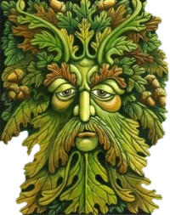
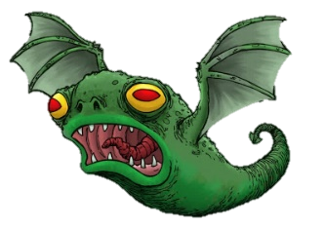
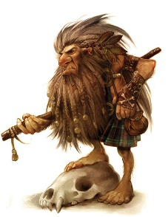

Green Man
Llamhigyn y Gwr
Coblynau

Wales
Reading comprehension (higher)

Read about “Welsh love spoons” and answer the questions.
A “lovespoon” is a decoratively carved wooden spoon that was traditionally presented as a gift of romantic intent. The spoon is normally decorated with symbols of love, and was intended to reflect the skill of the carver.
The craft dates back to the seventeenth century. Over generations, decorative carvings were added to the spoon and it lost its original practical use and became a treasured decorative item to be hung on a wall.
The earliest known dated lovespoon from Wales is from 1667, although the tradition is believed to date back long before that. The lovespoon was given to a young woman by her suitor. It was important for the girl's father to see that the young man was capable of providing for the family and woodworking.
Sailors would often carve lovespoons during their long journeys, which is why anchors would often be incorporated into the carvings.
Certain symbols came to have specific meanings: a horseshoe for luck, a cross for faith, bells for marriage, hearts for love, a wheel supporting a loved one and a lock for security, among others. Caged balls indicated the number of children hoped for. Other difficult carvings, such as chains, were as much a demonstration of the carver's skill as a symbolic meaning.^{[4]}
Although the Welsh lovespoon is the most famous there are also traditions of lovespoons in Scandinavia^{[5]} and some parts of Eastern Europe, which have their own unique styles and techniques.
Today lovespoons are given as wedding and anniversary gifts, as well as birthday, baby gifts, Christmas or Valentine's Day gifts. They are now mostly seen as a folk craft.

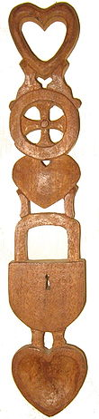
True or False?

- The spoons are no longer used for eating.

- Young women would give spoons to their boyfriends.

- Every image on the spoon must have a symbolic meaning.

- Lovespoons are found in other parts of Europe, but they look different.

Wales
Reading comprehension (higher)

Read about “Welsh love spoons” and answer the questions.
A “lovespoon” is a decorated wooden spoon that was traditionally given as a romantic gift. The spoon is normally decorated with symbols of love, and was a chance for the maker to show his skill.
The craft began in the seventeenth century. Over time, more complex carvings were added to the spoon and it lost its original practical use and became a treasured decorative item to be hung on a wall.
The oldest lovespoon from Wales is from 1667, but the tradition is believed be much older. The lovespoon was given to a young woman by her boyfriend. It was important for the girl's father to see that the young man could provide for the family.
Sailors would often make lovespoons during their long journeys, which is why anchors would often be a part of the design.
Certain symbols came to have specific meanings: a horseshoe for luck, a cross for faith, bells for marriage, hearts for love, a wheel supporting a loved one and a lock for security, among others. Caged balls indicated the number of children hoped for. Other difficult carvings, such as chains, were simply a chance for the maker to show his skill.
Although the Welsh lovespoon is the most famous there are also traditions of lovespoons in Scandinavia^{[5]} and some parts of Eastern Europe, which have their own unique styles and techniques.
Today lovespoons are given as wedding and anniversary gifts, as well as birthday, baby gifts, Christmas or Valentine's Day gifts. They are now mostly seen as a folk craft.

True or False?

- The spoons are no longer used for eating.

- Young women would give spoons to their boyfriends.

- Every image on the spoon must have a symbolic meaning.

- Lovespoons are found in other parts of Europe, but they look different.

