Map of the U.S.A.
Task 1: Look at the map of the U.S.A. and count how many states there are. Try to remember names of the states.

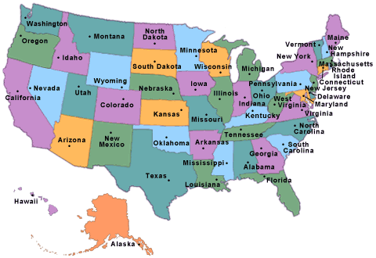

Task 2: Don’t look at the map and try to see how many states you remember.

Task 3: In small groups brainstorm how much you know about the U.S.A. and present your idea in the form of a mind-map.

Map of the U.S.A.
NOTES FOR TEACHERS

- This could be the first lesson you do with your students.
- Work on the pronunciation of the states’ names. Use in class, or encourage students to use at home http://howjsay.com to check the pronunciation of every name. There will be a few surprises.
- Once the students have studied the map and worked on the names of different states, you may ask them to draw the map of the USA from memory.
- For homework, you may ask the class to check the capitals of every state.
- Before students start working on Task 3, explain the concept of a mind map. If possible, distribute A3 or poster size sheets of paper and colour pens. Later, ask the groups to present their mind-maps to the rest of the class.

Here is a little cribsheet for you, an exactract from http://en.wikipedia.org/wiki/United_States, so that you’re ahead of your students.

The United States of America (USA), commonly referred to as the United States (US), America, or simply the States, is a federal republic consisting of 50 states, 16 territories, a federal district, and various overseas extraterritorial jurisdictions. The 48 contiguous states and the federal district of Washington, D.C., are in central North America between Canada and Mexico. The state of Alaska is the northwestern part of North America and the state of Hawaii is an archipelago in the mid-Pacific. The country also has five populated and nine unpopulated territories in the Pacific and the Caribbean. At 3.79 million square miles (9.83 million km²) in total and with around 316 million people, the United States is the fourth-largest country by total area and third largest by population. It is one of the world's most ethnically diverse and multicultural nations, the product of large-scale immigration from many countries. The geography and climate of the United States is also extremely diverse, and it is home to a wide variety of wildlife.
Paleo-indians migrated from Asia to what is now the US mainland around 15,000 years ago, with European colonization beginning in the 16th century. The United States emerged from 13 British colonies located along the Atlantic seaboard. Disputes between Great Britain and these colonies led to the American Revolution. On July 4, 1776, delegates from the 13 colonies unanimously issued the Declaration of Independence. Theensuing war ended in 1783 with the recognition of independence of the United States from the Kingdom of Great Britain, and was the first successful war of independence against a European colonial empire The current Constitution was adopted on September 17, 1787. The first 10 amendments, collectively named the Bill of Rights, were ratified in 1791 and guarantee many fundamental civil rights and freedoms.
Driven by the doctrine of manifest destiny, the United States embarked on a vigorous expansion across North America throughout the 19th century. This involved displacing native tribes, acquiring new territories, and gradually admitting new states. The American Civil War ended legalized slavery in the United States. By the end of the 19th century, the United States extended into the Pacific Ocean,^{[18]} and its economy was the world's largest. The Spanish–American War and World War I confirmed the country's status as a global military power. The United States emerged from World War II as a global superpower, the first country with nuclear weapons, and a permanent member of the United Nations Security Council. The end of the Cold War and the dissolution of the Soviet Union left the United States as the sole superpower.
The United States is a developed country and has the world's largest national economy, with an estimated GDP in 2013 of $16.7 trillion – 19% of global GDP at purchasing-power parity. The per capita GDP of the U.S. was the world's sixth-highest in 2010 and the U.S. has the highest mean and second-highest median household income in the OECD as well as the highest average wage. The U.S. has the fourth most unequal income distribution among OECD nations with roughly 16% of the population living in poverty. The economy is fueled by an abundance of natural resources, a well-developed infrastructure, and high productivity and while its economy is considered post-industrial the US continues to be one of the world's largest manufacturers. The country accounts for 39% of global military spending being the foremost economic and military power, a prominent political and cultural force in the world, and a leader in scientific research and technological innovation.

