CHRISTMAS TRADITIONS IN THE UNITED KINGDOM
Look at the picture and complete the sentences below with “be” using the correct form to say what the children are doing now.
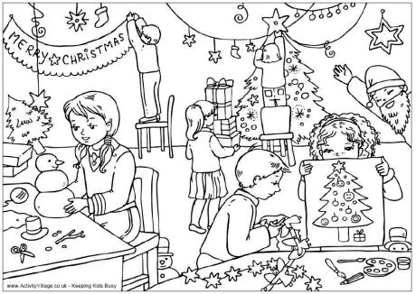

- Kamila ____ __________ a snowman. (make)
- Pedro ____ __________ ____ decorations. (cut out)
- Giuseppe ____ __________ a fake beard. (wear)
- Helga ____ __________ the presents to the tree. (carry)
- Svitlana ____ __________ an angel on top of the tree. (not put)
- Anna ____ __________ her picture to Pedro. (show)
- All of the children ____ __________ ready for Christmas. (get)

CHRISTMAS TRADITIONS IN THE UNITED KINGDOM
Teachers’ Notes
You can follow up this simple activity by showing your students your own Christmas photos from previous years and ask them to tell you what you and your family are doing in the pictures.

