GREAT BRITAIN IN 10 PICTURES
Burns Night
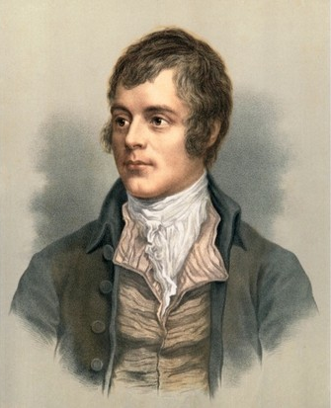
Task 1: INTRODUCTION

Talk to your partner and discuss the following questions:

- Does your country have a national poet/poets?
- What are some of their most famous works?
- How are they remembered today? e.g. with statues

Task 2: READING

What is Burns Night and who was Robert Burns?

Burns Night marks the anniversary of Scottish national poet Robert Burns’ birth on 25 January each year. Held throughout the world on Burns Night (or on an evening close to it) a traditional Burns supper is an evening event that celebrates Robert Burns’ life and work.
The first Burns supper was held in July 1801 when nine of Burns’ close friends got together to mark the fifth anniversary of their friend’s death. Taking place at Burns Cottage in Alloway, the night included a tasty meal (haggis, of course!), performances of Burns’ work and a speech in honour of the great Bard (now known as the Immortal Memory). The night was such a resounding success they decided to hold it again (this time in honour of Rabbie’s birthday), beginning the tradition we still enjoy to this day.
Everyone enjoys a hearty feast (which includes haggis, neeps and tatties, rounded off with drams of whisky), some of Burns’ poems and songs are recited and tributes are made to the great Bard.
Each Burns supper is individual, but the running order normally goes something like this:
- To start – everyone gathers, the host says a few words, everyone sits and the Selkirk Grace is said.
- The meal – the starter is served, the haggis is piped in, the host performs Address to a Haggis, everyone toasts the haggis and the main meal is served, followed by dessert.
- After the meal – the first Burns recital is performed, the Immortal Memory(the main tribute speech to Burns) is given, the second Burns recital is performed, then there’s a Toast to the Lassies, followed by a Reply to the Toast to the Lassies, before the final Burns recital is performed.
- To end the night – the host gives a vote of thanks, everyone stands and sings Auld Lang Syne, crossing their arms and joining hands at the line ‘And there's a hand, my trusty fere!’.
]Now read the text again and decide if the following sentences are true or false
- Burns Night takes place after New Year’s Day.
- The celebrations start in the morning.
- The first Burns Night took place four years after the poet died.
- The poem “Address to a Haggis” is performed after the main meal.
- At the end of the night, everybody joins hands to sing a traditional song.

Task 3: VOCABULARY

Find words in the text with the following meanings:

DEFINITION  Another word for “dinner”  The date one year after an event  Big and comforting (talking about food)  Something which cannot die  A Scots word meaning “girls” | WORD

Write one sentence using each word. Say the sentence to your partner with the target word blanked out. Can they guess the missing word?

Task 4: Design a festival

Discuss with your partner how you could celebrate a writer from your country
Which of his/her poems would be read? At what point in the day?
What food would be served? Would there be any music or other performances?
Would people have to wear special clothes or perform any special rituals?

BRITAIN IN 10 PICTURES
Burns Night
Teachers’ Notes
This activity has been designed for pre-intermediate, intermediate and upper-intermediate students to be used before the event as an introduction and a way of getting students interested in the subject.

You may follow up the exercises with a class debate or series of speeches/presentations followed by question and answer sessions or further research into the relevant topics.

Answers are as follows:

Task 2

- true
- false
- false
- false
- true
Task 3
DEFINITION  Another word for “dinner”  The date one year after an event  Big and comforting (talking about food)  Something which cannot die  A Scots word meaning “girls” | WORD  Supper  An anniversary  Hearty  Immortal  Lassies

