GREAT BRITAIN IN 10 PICTURES
Edinburgh
Task 1: INTRODUCTION
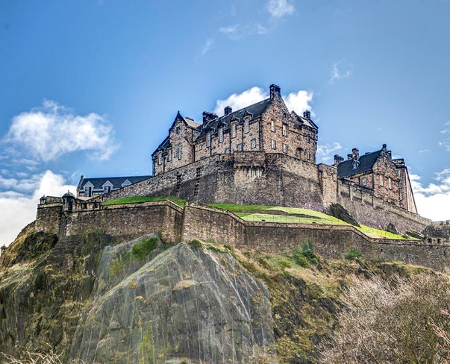
Talk to your partner and discuss the following questions:

- Are there any famous castles in your country?
- What makes a good place to build a castle?
- What different features do castles often have
which make them easy to defend?

Task 2: READING

What different things has Edinburgh Castle been used for? Read and find out.

Set upon its mighty rock, Edinburgh Castle’s strategic advantage is clear. It was Iron Age warriors who first saw the site’s military potential and built a hill fort on the rock. Scotland’s oldest poetry tells of a war band that feasted here for a year before riding to its death in battle.
Edinburgh Castle was home to kings and queens. Queen Margaret (who was later made a saint) died here in 1093. The chapel built in her honour by her son, King David I, is Edinburgh’s oldest building. St Margaret’s Chapel still hosts weddings and christenings today. The Great Hall, completed in 1511 for King James IV, hosted grand banquets and state events. But the king had little time to enjoy his new addition. James IV died fighting the forces of King Henry VIII of England – his brother-in-law – at the Battle of Flodden in 1513. Above the door to the Royal Palace are the gilded initials MAH – for Mary Queen of Scots and her second husband Henry Stewart, Lord Darnley. Mary gave birth to James VI in the Royal Palace in 1566. He became king of Scotland at 13 months old and united the crowns of Scotland and England in 1603.
Not everyone who came to the castle enjoyed their stay. While royal guests dined and danced in the Great Hall, life was grim for the pirates and prisoners of war locked up in the vaults below. In 1720, 21 Caribbean pirates were held here after being captured off Argyll. Many of the later prisoners of war were also sailors – from France, America, Spain, the Netherlands, Ireland, Italy, Denmark and Poland. The first prisoners of war were French privateers caught in 1758, soon after the Seven Years War began. A five-year-old drummer boy taken at the Battle of Trafalgar in 1805 was the youngest captive. Some lucky souls managed to break out. In 1811, 49 French prisoners of war hacked through a castle wall. All but one of them got away by using ropes to escape down the south crag.

Now read the text again and decide if the following sentences are true or false
- Edinburgh Castle was built by King David I.
- James VI was very old when he became King of Scotland.
- The castle was also used as a prison.
- Many of the people kept in the dungeon were sailors.
- Nobody has ever escaped from the castle.

Task 3: VOCABULARY

Find words in the text with the following meanings:

DEFINITION  Another word for a soldier or fighter  A small version of a church, used for prayer  A huge meal for many people  Covered in gold  To join two or more things together  Depressing, unpleasant  Rooms underneath a building  Another word for a prisoner | WORD

Write one sentence using each word. Say the sentence to your partner with the target word blanked out. Can they guess the missing word?

Task 4: Research

Choose a castle in your country and find the answers to these questions:
When was the castle built? Who were the first people to live in it? Has it been expanded since?
What defences does the castle have? Has it been a part of any major battles or sieges?
Have any important events taken place in or near the castle? What was their effect?
BRITAIN IN 10 PICTURES
London
Teachers’ Notes
This activity has been designed for pre-intermediate, intermediate and upper-intermediate students to be used before the event as an introduction and a way of getting students interested in the subject.

You may follow up the exercises with a class debate or series of speeches/presentations followed by question and answer sessions or further research into the relevant topics.

Answers are as follows:

Task 2

- false
- false
- true
- true
- false
Task 3
DEFINITION  Another word for a soldier or fighter  A small version of a church, used for prayer  A huge meal for many people  To join two or more things together  Depressing, unpleasant  Rooms underneath a building  Another word for a prisoner | WORD  A warrior  A chapel  Banquet  To unite  Grim  Vaults  A captive

