GREAT BRITAIN IN 10 PICTURES
Food in the UK

Task 1: INTRODUCTION

Talk to your partner and discuss the following questions:

- What can you see in the images below? Do you know anything about these dishes?
- Have you tried any of the food in the pictures? Did you like it?
- What food from your country do you think a foreigner would find strange?
- What dishes from your country would you recommend?

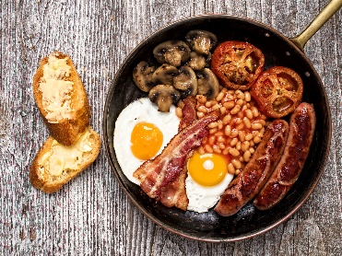
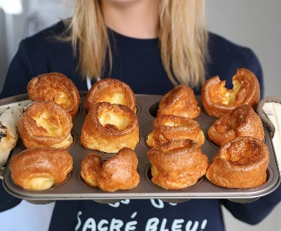
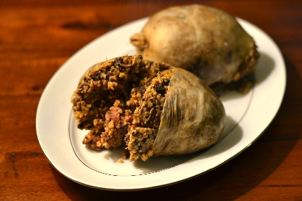
1 2 3 4
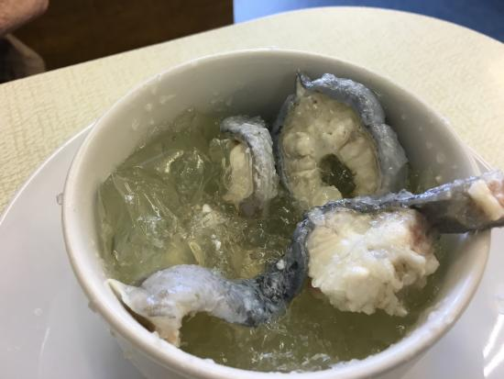

5 6 7 8
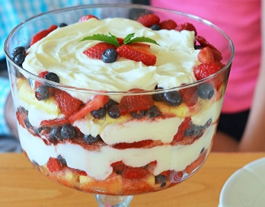
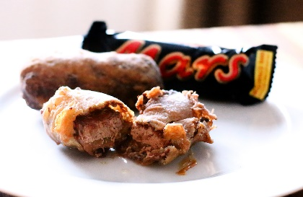
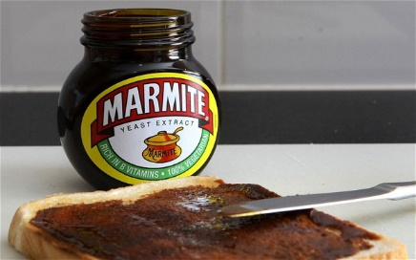
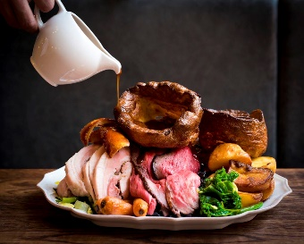

Task 2: READING

Match the descriptions on the next page with the eight photographs of food above. Compare your answers with a partner. Which dishes do you think sounds most/least appetizing?

Description | Image
A spread made from yeast. It has a strong, unique flavour and was marketed with the slogan “You either love it or you hate it.”
The Full English Breakfast is made from many ingredients which can change depending on region or personal taste, but always includes bacon, eggs and beans.
Now mostly a novelty, jellied eels were once very popular among the working class in London, as they were cheap and easy to catch from the river Thames.
Trifle is a traditional British desert made from jelly, custard, whipped cream, fresh fruits and spongey biscuits called “Ladies’ Fingers”.
Haggis is a Scottish delicacy made from the heart, liver and lungs of a sheep, minced and boiled in its stomach.
Yorkshire Puddings are simple bowl-shaped puddings made from batter, usually eaten as part of a Sunday Roast.
Another Scottish invention, the notorious Deep Fried Mars Bar was invented in the Fish and Chip shops of Glasgow.
The Sunday Roast is permanent British favourite, consisting of roast vegetables, potatoes, meat and a meaty sauce called “gravy”.

Task 3: VOCABULARY

Find words in the text with the following meanings:

DEFINITION  A phrase used to sell a product, e.g. “Just Do It”  Something enjoyed simply because it is unusual  A type of food considered especially delicious  A simple mixture of flour, water and eggs  Famous for something bad, e.g. a well-known criminal  An expression meaning “made from” or “including” | WORD

BRITAIN IN 10 PICTURES
Food in the UK
Teachers’ Notes
This activity has been designed for pre-intermediate, intermediate and upper-intermediate students to be used before the event as an introduction and a way of getting students interested in the subject.

You may follow up the exercises with a class discussion or series of presentations followed by question and answer sessions or further research into the relevant topics.

Answers are as follows:

Task 2

7
2
4
6
1
3
5
8

Task 3
DEFINITION  A phrase used to sell a product, e.g. “Just Do It”  Something enjoyed simply because it is unusual  A type of food considered especially delicious  A simple mixture of flour, water and eggs  Famous for something bad, e.g. a well-known criminal  An expression meaning “made from” or “including” | WORD  Slogan  A novelty  A delicacy  Batter  Notorious  Consisting of

