GREAT BRITAIN IN 10 PICTURES
London
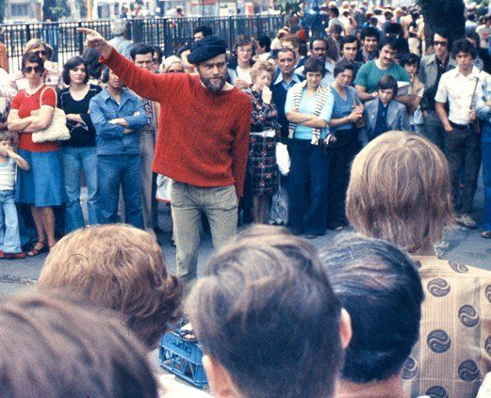
Task 1: INTRODUCTION

Talk to your partner and discuss the following questions:

- What can you see in the image opposite?
- What do you think the man is talking about?
- What skills do you need to be a good public speaker?

Task 2: READING

What is Speaker’s Corner? Read the text and find out.

A Speakers' Corner is an area where open-air public speaking, debate, and discussion are allowed. The original and most noted is in the northeast corner of Hyde Park in London, England. Speakers here may talk on any subject, as long as the police consider their speeches lawful, although this right is not restricted to Speakers' Corner only.
Contrary to popular belief, there is no immunity from the law, nor are any subjects forbidden, but in practice the police intervene only when they receive a complaint. On some occasions in the past, they have intervened on grounds of profanity. Speakers' Corner is often held up to demonstrate freedom of speech, as anyone can turn up unannounced and talk on almost any subject, although always at the risk of being heckled by regulars.
One important judge described Speakers' Corner as demonstrating "the tolerance which is both given by the law to opinion of every kind and expected by the law of those who disagree, even strongly, with what they hear." This judge established that freedom of speech could not be limited to the inoffensive but extended also to "the irritating, the contentious, the eccentric, the heretical, the unwelcome, and the provocative, as long as such speech did not tend to provoke violence".
Before this decision, prohibited speech at Speakers' Corner included, obscenity, blasphemy, insulting the queen, or inciting a breach of the peace.
Now read the text again and decide if the following sentences are true or false
- Speaker’s Corner in Hyde Park is the only such place in the world.
- You can say things at Speaker’s Corner that you can’t say elsewhere in Britain.
- The Police have the power to interrupt somebody’s speech.
- You have to make a reservation if you want to speak at Speaker’s Corner.
- Today you are allowed to say bad things about the Queen in Hyde Park.

Task 3: VOCABULARY

Find words in the text with the following meanings:

DEFINITION  Sharing ideas between two or more people  Allowed by law  Not allowed  Swearing or saying vulgar things  To shout at somebody during a performance  A person who decides is something is against the law  To try to make somebody act a certain way  Saying things which insult or attack religion | WORD

Write one sentence using each word. Say the sentence to your partner with the target word blanked out. Can they guess the missing word?

Task 4: SPEAKING

Discuss the following questions with a partner:
Do you think that freedom of speech should have limits? If so, what should they be?
If you were to give a speech in Speaker’s Corner, what would you speak about?
Is there a difference between things people should be allowed to say in the street or at home and, for example, on the television or radio? How about the internet or in newspapers?

BRITAIN IN 10 PICTURES
London
Teachers’ Notes
This activity has been designed for pre-intermediate, intermediate and upper-intermediate students to be used before the event as an introduction and a way of getting students interested in the subject.

You may follow up the exercises with a class debate or series of speeches/presentations followed by question and answer sessions or further research into the relevant topics.

Answers are as follows:

Task 2

- false
- false
- true
- false
- true
Task 3
DEFINITION  The sharing of ideas between people  Allowed by law  Not allowed  Swearing or saying vulgar things  To shout at somebody during a performance  A person who decides is something is against the law  To try to make somebody act a certain way  Saying things which insult or attack religion | WORD  Discussion  Lawful  Forbidden  Profanity  To heckle  A judge  To provoke  Blasphemy

