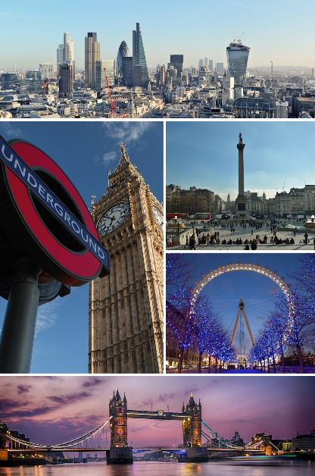
GREAT BRITAIN IN 10 PICTURES
The South of England
Task 1: INTRODUCTION

Talk to your partner and discuss the following questions:

- What city can you see in the image opposite?
- How many other cities in the UK can you name?
- Do you know anything that these cities are famous for?

Task 2: READING

Where does the city of Bath’s name come from? Read and find out.

Bath is the largest city in the county of Somerset, England, known for its Roman-built baths. The city became a World Heritage site in 1987.
The city became a spa with the Latin name Aquae Sulis ("the waters of Sulis") c. 60 AD when the Romans built baths and a temple in the valley of the River Avon, although hot springs were known even before then.
In the 17th century, claims were made for the curative properties of water from the springs, and Bath became popular as a spa town in the Georgian era. Georgian architecture, crafted from Bath stone, includes the Royal Crescent, Circus, Pump Room and Assembly Rooms.
In the 18th century the city became fashionable and the population grew. Jane Austen lived in Bath in the early 19th century. Further building was undertaken in the 19th century and following the Bath Blitz in World War II.
The city has software, publishing and service-oriented industries. Theatres, museums and other cultural and sporting venues have helped make it a major centre for tourism, with more than one million staying visitors and 3.8 million day visitors to the city each year.
The Royal Crescent
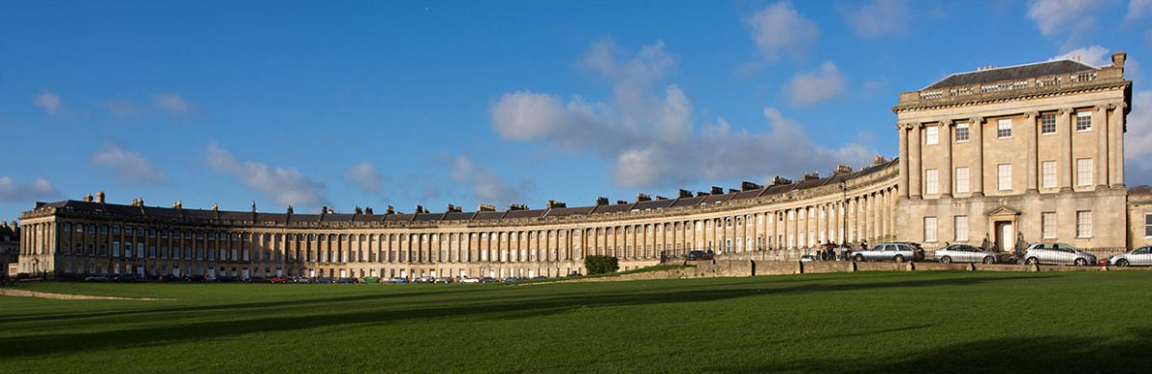
Now read the text again and decide if the following sentences are true or false
- The famous baths were built by English people.
- Bath is notable for its distinctive architecture.
- Many people moved to Bath in the 1700s.
- The city was mostly undamaged during the Second World War.
- Today Bath remains very popular with tourists.

Task 3: VOCABULARY

Find words in the text with the following meanings:

DEFINITION  An administrative region of the UK  A place where people go to worship gods  A place where hot water is found naturally  The number of people who live in a city  The name for the time when Britain was bombed during the Second World War  A place where events are held | WORD

Write one sentence using each word. Say the sentence to your partner with the target word blanked out. Can they guess the missing word?

Task 4: SPEAKING

Discuss the following questions with a partner:

What changes would you like to see to your town or city?
If a tourist was planning on visiting your town or city, what sites do you think they should see?
How much do you know about the history of your own town or city? In what ways has it changed in the last five, one hundred or five hundred years?
BRITAIN IN 10 PICTURES
The South of England
Teachers’ Notes
This activity has been designed for pre-intermediate, intermediate and upper-intermediate students to be used before the event as an introduction and a way of getting students interested in the subject.

You may follow up the exercises with a class debate or series of speeches/presentations followed by question and answer sessions or further research into the relevant topics.

Answers are as follows:

Task 2

- false
- true
- true
- false
- true
Task 3
DEFINITION  An administrative region of the UK  A place where people go to worship gods  A place where hot water is found naturally  The number of people who live in a city  The name for the time when Britain was bombed during the Second World War  A place where events are held | WORD  A county  A temple  A hot spring  The population  The Blitz  A venue

